U24AI047 AI LAB PRACTICAL-14

1. Write a program to solve the questions using Forward Chaining.
a. Knowledge Base:
P → Q
L ∧ M → P
A ∧ B → L
A
B
M
Conclusion:
Q
b. Knowledge Base:
A → B
B → C
C → D
A
E
D ∧ E → F
Conclusion: F

def pl_fc_entails(rules, known_facts, q):
# Initialize count table for each rule's premises
count = {i: len(premise) for i, (premise, conclusion) in enumerate(rules)}

# Gather all unique symbols and track inference status
symbols = set(known_facts)
for premise, conclusion in rules:
symbols.update(premise)
symbols.add(conclusion)
inferred = {s: False for s in symbols}

queue = list(known_facts)

print(f"--- Starting PL-FC-ENTAILS? ---\nInitial Queue: {queue}\nTarget: {q}\n")

while queue:
p = queue.pop(0)

if p == q:
print(f"\nSuccess! Found '{q}'.")
return True

if not inferred.get(p, False):
inferred[p] = True
print(f"Processing: {p}")

for i, (premise, conclusion) in enumerate(rules):
if p in premise:
count[i] -= 1
if count[i] == 0:
print(f" -> Rule {i} ({premise} -> {conclusion}) satisfied. Queuing '{conclusion}'.")
queue.append(conclusion)

print(f"\nFailure. '{q}' not entailed.")
return False

# Problem A
print("=== PROBLEM A ===")
rules_a = [(['P'], 'Q'), (['L', 'M'], 'P'), (['A', 'B'], 'L')]
facts_a = ['A', 'B', 'M']
pl_fc_entails(rules_a, facts_a, 'Q')

print("\n")

# Problem B
print("=== PROBLEM B ===")
rules_b = [(['A'], 'B'), (['B'], 'C'), (['C'], 'D'), (['D', 'E'], 'F')]
facts_b = ['A', 'E']
pl_fc_entails(rules_b, facts_b, 'F')

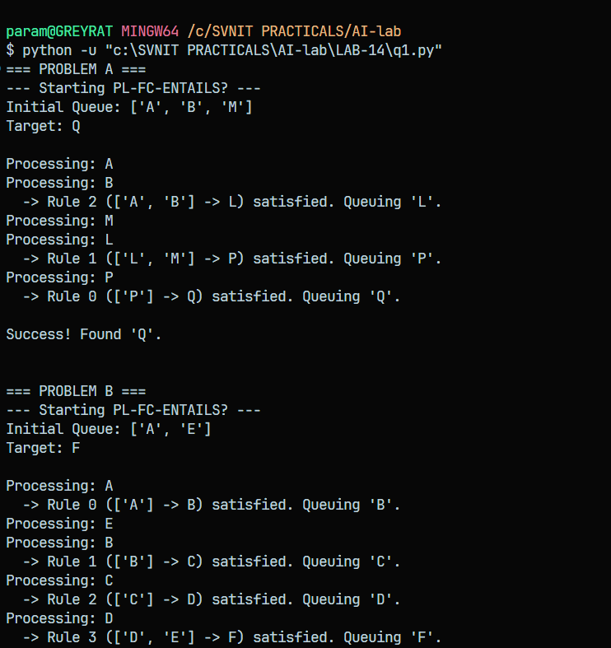

2. Write a program to solve the questions using Backward Chaining.
a. Knowledge Base:
P → Q
R → Q
A → P
B → R
A
B
Conclusion:
Q
b. Knowledge Base:
A → B
B ∧ C → D
E → C
A
E
Conclusion:
D

def pl_bc_entails(rules, known_facts, query):
def prove(q, path):
indent = " " * len(path)
print(f"{indent}[?] Attempting to prove: '{q}'")

if q in known_facts:
print(f"{indent}[+] Success: '{q}' is a known fact.")
return True

if q in path:
print(f"{indent}[-] Failure: Cycle detected for '{q}'.")
return False

for premises, conclusion in rules:
if conclusion == q:
print(f"{indent}[*] Found relevant rule: {premises} -> {conclusion}")

all_premises_proved = True
for p in premises:
if not prove(p, path + [q]):
all_premises_proved = False
print(f"{indent}[-] Premise '{p}' failed for rule {premises} -> {conclusion}")
break

if all_premises_proved:
print(f"{indent}[+] Success: Proved '{q}' via rule {premises} -> {conclusion}")
return True

print(f"{indent}[-] Failure: Exhausted all options for '{q}'.")
return False

print(f"--- Starting PL-BC-ENTAILS? ---\nTarget Query: {query}")
result = prove(query, [])
print(f"\nFinal Result: {'SUCCESS' if result else 'FAILURE'}\n")
return result

# Problem A
print("=== PROBLEM A ===")
rules_a = [(['P'], 'Q'), (['R'], 'Q'), (['A'], 'P'), (['B'], 'R')]
facts_a = ['A', 'B']
pl_bc_entails(rules_a, facts_a, 'Q')

# Problem B
print("=== PROBLEM B ===")
rules_b = [(['A'], 'B'), (['B', 'C'], 'D'), (['E'], 'C')]
facts_b = ['A', 'E']
pl_bc_entails(rules_b, facts_b, 'D')

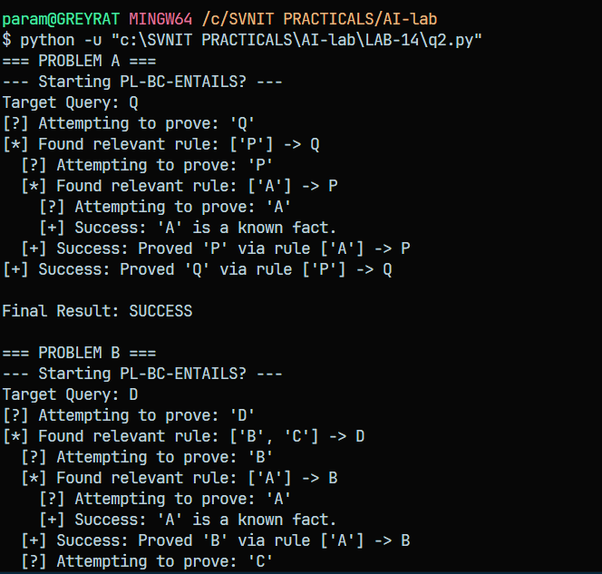

3. Write a program to solve the questions using the method Resolution and proof of
refutation/contradiction.

a. Knowledge Base:
P ∨ Q
P → R
Q → S
R → S
Conclusion
S
b. Knowledge Base:
P → Q
Q → R
S → ¬R
P
Conclusion:
S

def negate(literal):
return literal[1:] if literal.startswith('~') else '~' + literal

def resolve(clause1, clause2):
resolvents = set()
for l1 in clause1:
for l2 in clause2:
if l1 == negate(l2):
new_clause = (clause1 - {l1}) | (clause2 - {l2})
if not any(negate(lit) in new_clause for lit in new_clause):
resolvents.add(frozenset(new_clause))
return resolvents

def pl_resolution(kb_clauses, query):
negated_query = frozenset([negate(query)])
clauses = set(kb_clauses)
clauses.add(negated_query)

print(f"Initial Clauses (KB + Negated Query):")
for c in clauses: print(f" {set(c)}")
print("-" * 30)

new_clauses = set()

while True:
n = len(clauses)
clauses_list = list(clauses)

for i in range(n):
for j in range(i + 1, n):
resolvents = resolve(clauses_list[i], clauses_list[j])

if frozenset() in resolvents:
print(f"[*] Contradiction found! Resolved {set(clauses_list[i])} and {set(clauses_list[j])} -> Empty Clause")
return True

new_clauses.update(resolvents)

if new_clauses.issubset(clauses):
print("[-] No new clauses can be generated. No contradiction exists.")
return False

clauses.update(new_clauses)

print("=== SOLVING PROBLEM A ===")
kb_a = [
frozenset(['P', 'Q']),
frozenset(['~P', 'R']),
frozenset(['~Q', 'S']),
frozenset(['~R', 'S'])
]
query_a = 'S'

result_a = pl_resolution(kb_a, query_a)
print(f"Final Conclusion for A: The query '{query_a}' is {'PROVEN' if result_a else 'NOT PROVEN'}.\n")

print("=== SOLVING PROBLEM B ===")
kb_b = [
frozenset(['~P', 'Q']),
frozenset(['~Q', 'R']),
frozenset(['~S', '~R']),
frozenset(['P'])
]
query_b = 'S'

result_b = pl_resolution(kb_b, query_b)
print(f"Final Conclusion for B: The query '{query_b}' is {'PROVEN' if result_b else 'NOT PROVEN'}.")

